Megan Mosier
Module 2.3
Aril 4, 2026

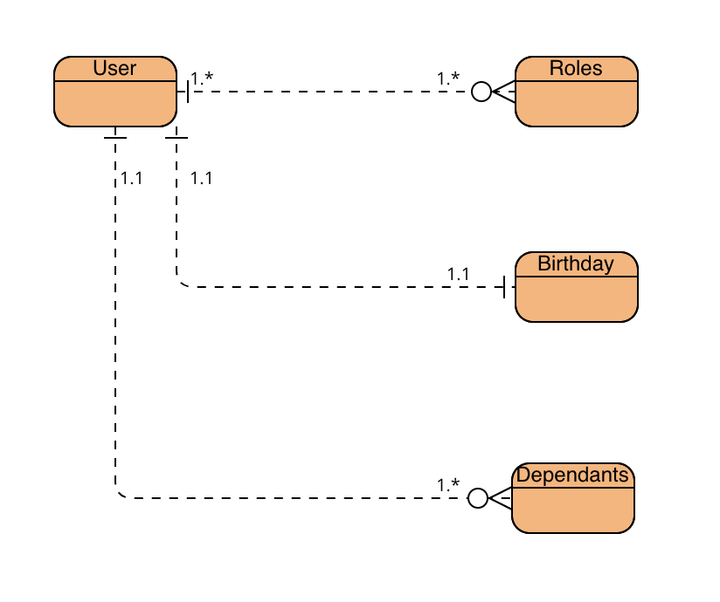
{
“first_name”: “Moira”,
“last_name”: “Rose”,
“roles”: [
{
“type”: “Mom”,
},
“type”: “Actress”,
},
]
“dependants”:[
{
“type”: “son”,
},
[
“type”: “daughter”,
}
]
}

